# **IAM Assignment**

Creating IAM Admin Group:

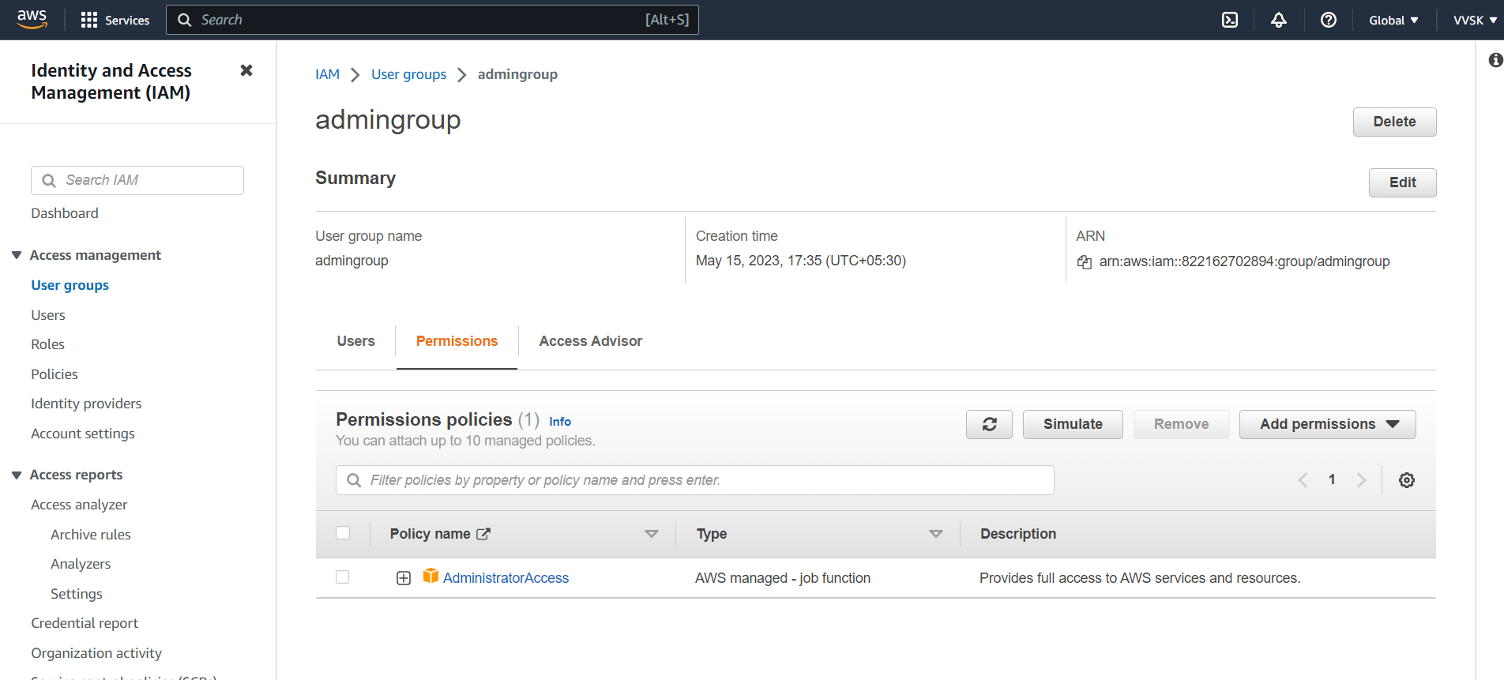

Creating AdminUser under AdminGroup

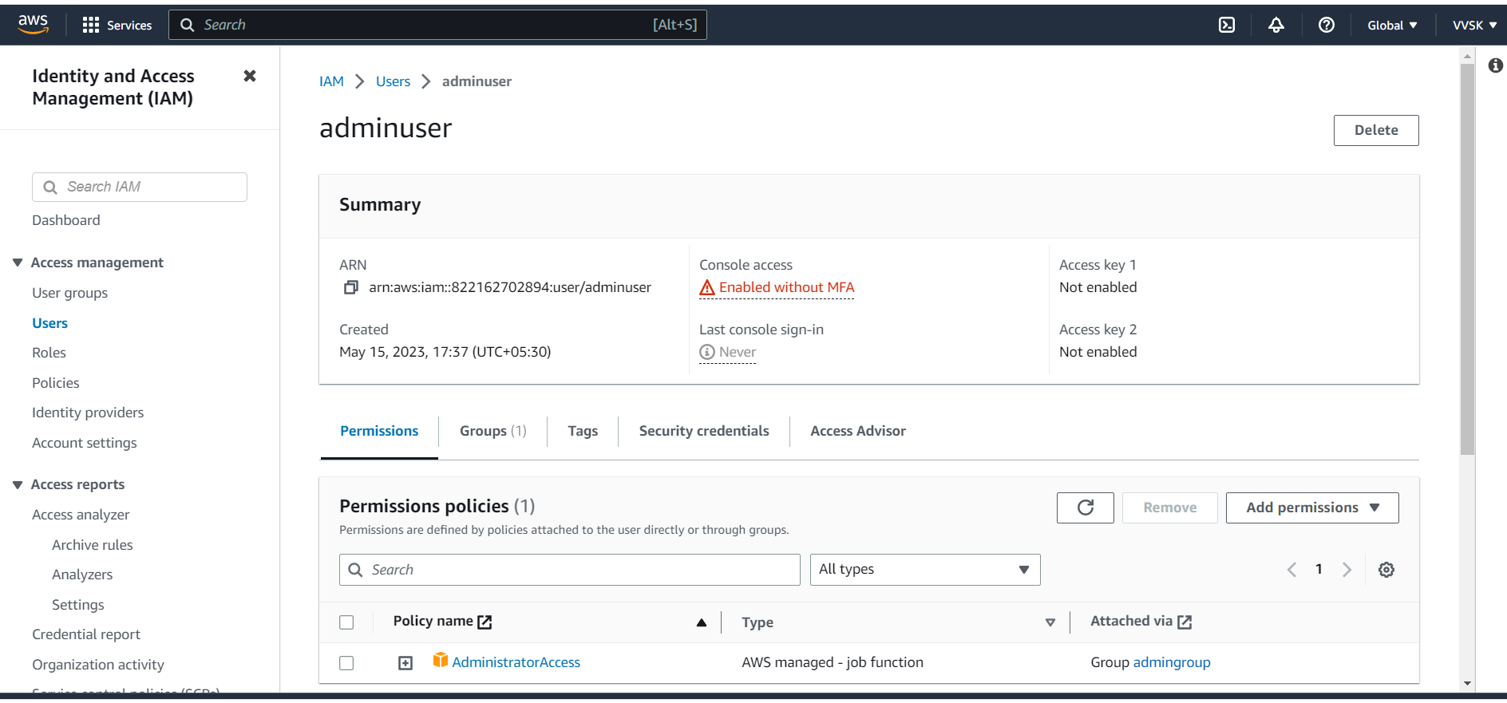

Creating Instance with adminuser

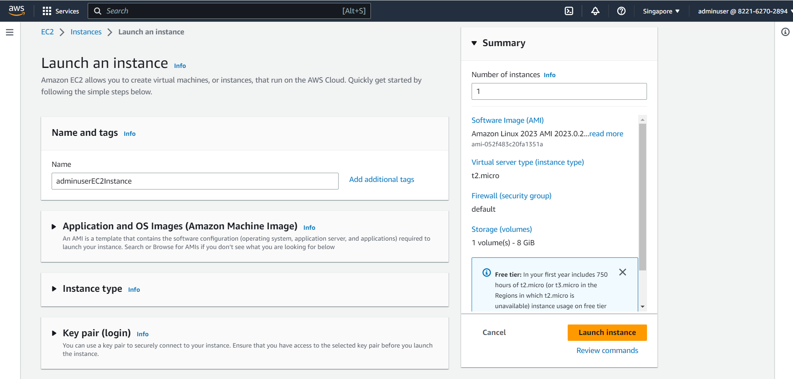

EBS Volume settings

Instance Created( adminuserEC2Instance )

EBS Volume details

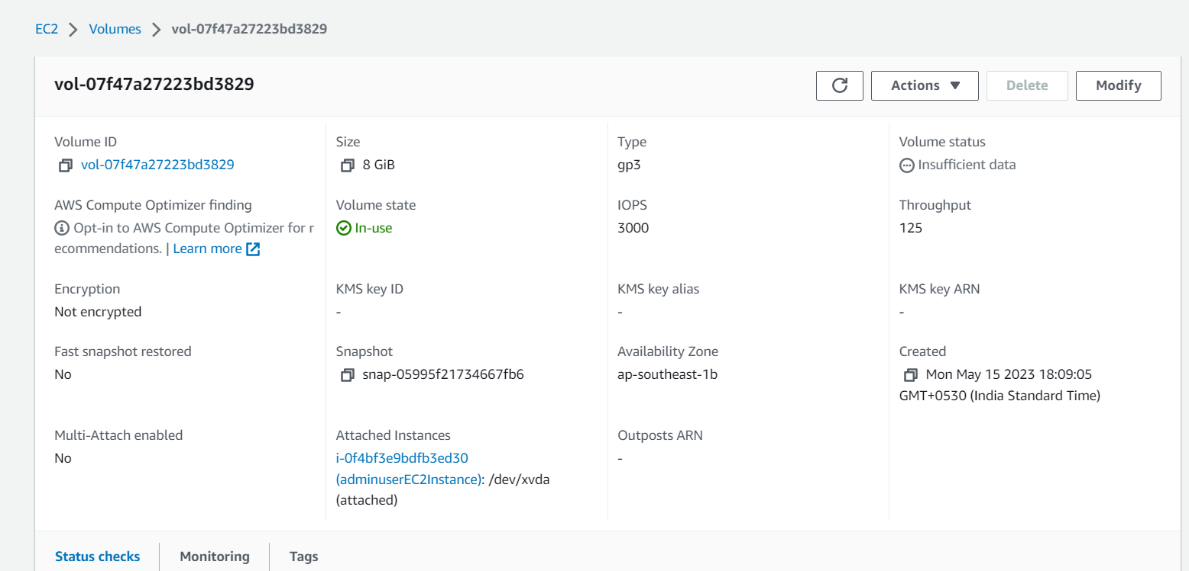

Terminating **adminuserEC2Instance**

EBS Volume deleted post terminating EC2 Instance

